Match The Correct Vocabulary Term:
Instructions: Fill in the corresponding letter on the answer sheet. Be sure to put your name, class period, and student ID code on your answer sheet.

- a ball hit along the ground –
a) infielder b) groundball
- a large number gathered together –
a) exaggerate b) flock
- a man stationed at a base –
a) baseman b) varsity
- a plan of action to achieve an overall goal –
a) victorious b) strategy
- a principal team representing a high school or college competition –
a) varsity b) compete
- a smaller divided section of time throughout a year –
a) compete b) season
- an event or occurrence –
a) incident b) advance
- competitive or opposing action –
a) conflict b) granted
- great enjoyment –
a) confident b) relish
- having or showing assurance and reliance in oneself -
a) granted b) confident
- having won a competition –
- compete b) victorious
- one of four players (1st, 2nd, 3rd basemen, and shortstop) stationed around the interior area of a baseball field –
- baseman b) infielder

- the quality of having experience, knowledge, and/or good judgement –
a) confident b) wisdom
- To accept without question or objection; to assume –
a) relish b) granted
- to achieve a desired result –
a) succeed b) granted
- to lower the body stance by bending the legs –
a) flock b) crouch
- to raise to a higher rank –
a) advance b) succeed
- to represent something as larger, greater, better, or worse than it really is –
a) exaggerate b) granted
- to strive for an object or a state of rivalry –
a) conflict b) compete
- to understand –
a) unfortunate b) comprehend
- unlucky –
- unfortunate b) relish

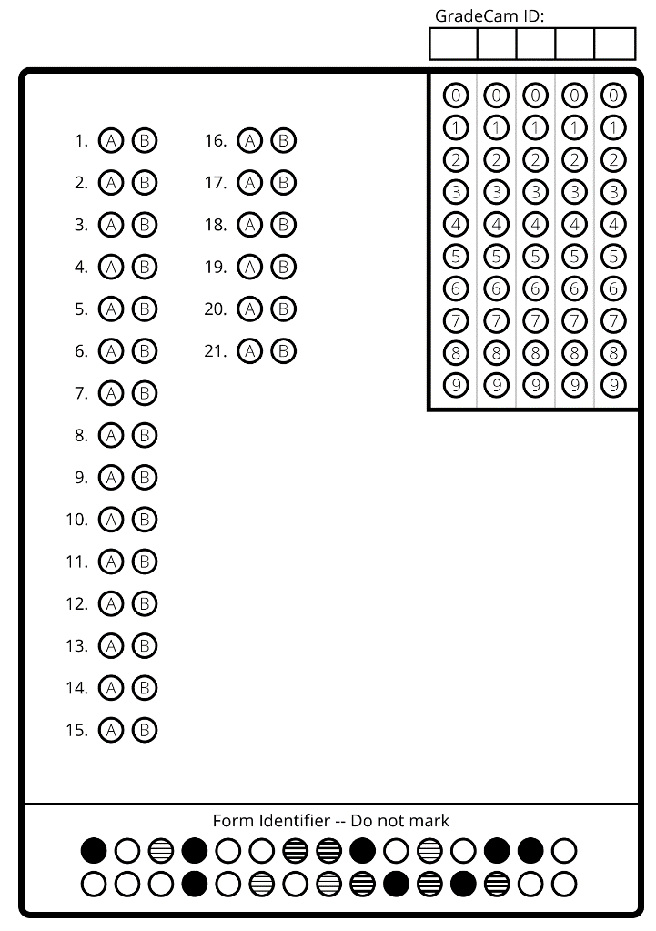
Name:___________________
Date:____________________
Period:___________________
Name:___________________
Date:____________________
Period:___________________
Name:___________________
Date:____________________
Period:___________________
Name:___________________
Date:____________________
Period:___________________

